**Password based Door lock system using 8051 Microcontroller**

**Project Title:** PASSWORD BASED DOOR LOCK SYSTEM

USING 8051 MICROCONTROLLER

**Introduction:**

Automated systems have less manual operations, so that the flexibility, reliabilities are high and accurate. Nowadays most of the systems are automated in order to face new challenges and present day requirements to achieve good results.

**Objective:**

Our objective is to utilize different electronic parts available in the market and build an integrated home security system based on ICs, Microcontroller and LCD screen and another main objective of designing this password based door lock system is to provide many modern security features than mechanical lock.

**Principle:**

The password which is entered through the 4X3 Keypad is compared with the predefined password. If the entered password is correct, then the system opens the door by rotating door motor and displays the status of door on LCD. If the password is wrong, then door is remain closed and displays “Password is wrong” on LCD.

**Hardware Required:**

1. 8051 Microcontroller developer board
2. Connecting wires
3. 4 * 4 Matrix Keypad
4. 16 *2 LCD display
5. DC Motor
6. L293D Motor Driver
7. Power
8. Ground

**Proteus Design:**

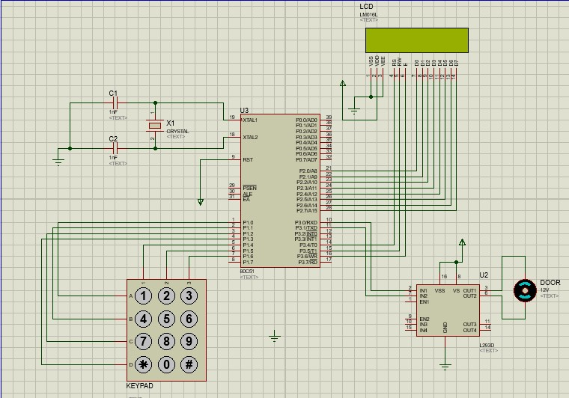

Description of Components:

L.C.D: Here we are using a 16x2 L.C.D which is a Liquid Crystal Display. Its function is to display the alphanumeric symbols to indicate the status message of the circuit. This L.C.D can display the two lines and each line contains 16 characters.

Data pins of LCD is connected to port P2 from P2.0-P2.7 describing the current status of system and three control pins RS, RW and E are connected to port P3 from P3.4- P3.6 respectively.

D.C Motor Drive: It is a machine used to convert the electrical energy into mechanical energy. This D.C motor uses a 5V battery as an input and rotates to open the door or to lock the door. To interface this D.C motor drive with the Micro Controller we use an L293D I.C. Dc motor is connected to port P3 from P3.0-P3.1 .

4x4 Matrix Keyboard: This keyboard contains a number of switches arranged in a matrix format. Each rows and each column are connected to the pins of micro controller. This keyboard contains numbers from 0 to 9, a ‘*’ button and a ‘#’ button. These switches are generally a numbers of push buttons. With the help of this Keyboard an individual can enter the password to unlock the door. 4x4 keypad is connected to port P1 from P1.0-P1.7 allowing user to enter user id.

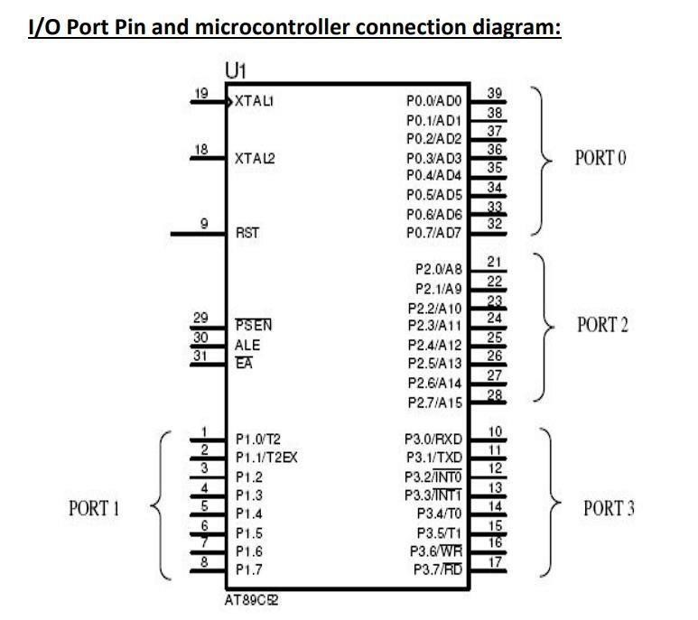

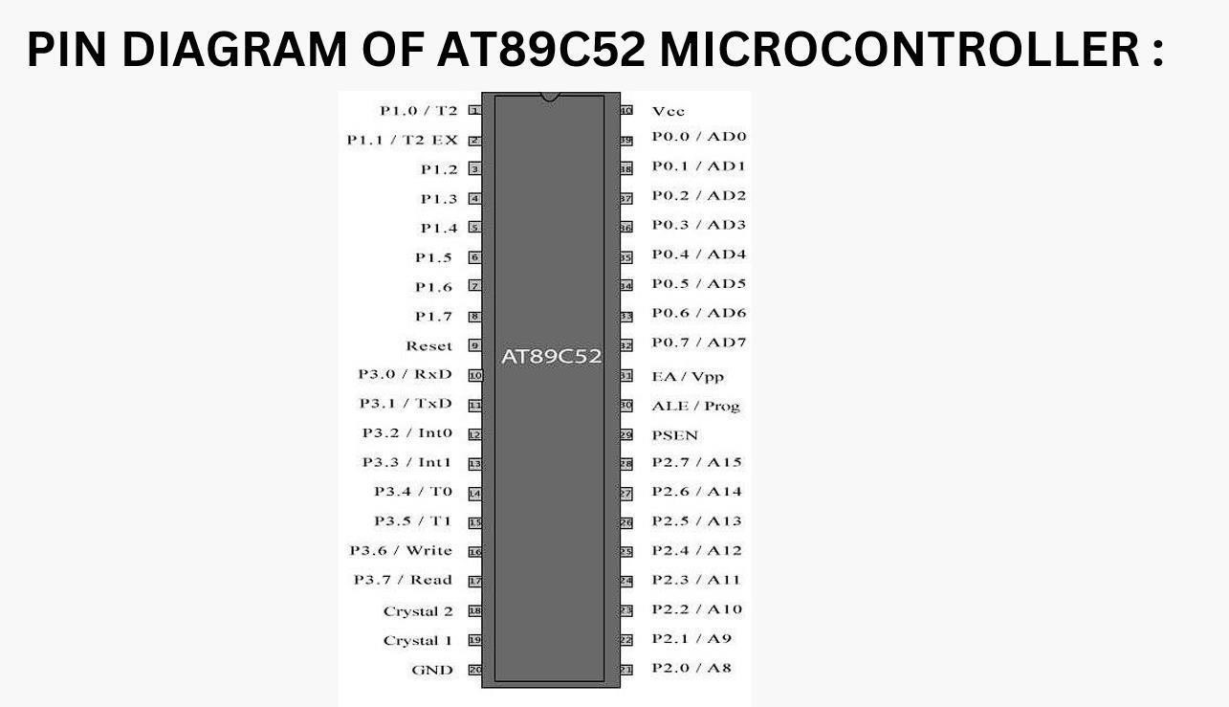

Application:

User can unlock the door using pre-defined passcode. When a user try to unlock the door using wrong passcode a message will be triggered. The door will automatically open when only passcode is matched. The main component in the circuit is 8051 micro controller which is basically used to send and accept text message from user. 4*4 Keypad is used to enter the password. The entered password is compared with the pre-defined password. If it is correct password, the system opens the door by rotating servo motor and display the status of the door on LCD. If the password is wrong then door remain closed and display message to the user.

Algorithm:

**ORG 0H**

**; Port initialization**

**MOV P0, #0FFH ; Set P0 as output for the control lines of the LCD display**

**MOV P1, #0FFH ; Set P1 as input for the 4x4 keypad**

**MOV P2, #0FFH ; Set P2 as output for the 14-pin LCD data lines**

**MOV P3, #0FFH ; Set P3 as output for motor control lines**

**; Define constants**

**DELAY_COUNT EQU 0C80H ; Hexadecimal value for the delay count (5 seconds)**

**CORRECT_PASSWORD_HIGH EQU 016H ; High byte of the correct password (56)**

**CORRECT_PASSWORD_LOW EQU 078H ; Low byte of the correct password (78)**

**MAIN:**

**CALL INIT_PORTS ; Initialize ports**

**CALL INIT_LCD ; Initialize the LCD**

**CALL GET_NEXT_DIGIT ; Get the entered password from the user**

**CALL CHECK_PASSWORD ; Check if the entered password is correct**

**JZ WRONG_PASSWORD ; If the password is wrong, display "Wrong Password"**

**CALL CLEAR_LCD ; Clear the LCD display**

**CALL DISPLAY_DOOR_OPENING ; Display "Door is opening" message**

**; Rotate the motor...**

**MOV P3, #01H ; Set P3.0 for the motor**

**CALL DELAY_MOTOR ; Delay for 5 seconds**

**MOV P3, #02H ; Set P3.1 for the motor**

**CALL DELAY_MOTOR ; Delay for 5 seconds**

**MOV P3, #00H ; Clear P3 to stop the motor**

**CALL DELAY_LCD ; Delay before clearing the LCD**

**CALL CLEAR_LCD ; Clear the LCD display**

**JMP MAIN ; Restart the process**

**WRONG_PASSWORD:**

**CALL CLEAR_LCD ; Clear the LCD display**

**CALL DISPLAY_WRONG_PASSWORD ; Display "Wrong Password" message**

**CALL CLEAR_LCD ; Clear the LCD display**

**JMP MAIN ; Restart the process**

**GET_NEXT_DIGIT:**

**; Initialize variables**

**MOV R2, #00H ; Initialize R2 to 0 (higher nibble)**

**MOV R3, #00H ; Initialize R3 to 0 (lower nibble)**

**; Scan rows of the keypad**

**MOV P1, #0FEH ; Enable row 0**

**MOV A, P1 ; Read columns**

**JNB P1.0, ROW0_CHECK ; Check if column 0 is low**

**JNB P1.1, ROW1_CHECK ; Check if column 1 is low**

**JNB P1.2, ROW2_CHECK ; Check if column 2 is low JNB P1.3, ROW3_CHECK ; Check if column 3 is low**

**ROW0_CHECK:**

**MOV R2, #01H ; Set R2 to 1 (digit 1, higher nibble)**

**JMP KEY_READ_DONE ; Exit the loop**

**ROW1_CHECK:**

**MOV R2, #02H ; Set R2 to 2 (digit 2, higher nibble)**

**JMP KEY_READ_DONE ; Exit the loop**

**ROW2_CHECK:**

**MOV R2, #03H ; Set R2 to 3 (digit 3, higher nibble)**

**JMP KEY_READ_DONE ; Exit the loop**

**ROW3_CHECK:**

**MOV R2, #0AH ; Set R2 to 10 (digit 0, higher nibble)**

**JMP KEY_READ_DONE ; Exit the loop**

**KEY_READ_DONE:**

**; Now, R2 contains the higher nibble of the digit read from the keypad**

**; Process the digit and update R0 accordingly**

**ADD A, R2 ; Add the higher nibble to the accumulated password**

**MOV R0, A ; Update R0 with the accumulated password**

**; Display the digit on the LCD**

**CALL DISPLAY_ON_LCD ; Call subroutine to display on LCD**

**; Shift R0 to make room for the lower nibble**

**MOV A, R0 ; Copy the accumulated password**

**SWAP A ; Swap the nibbles**

**MOV R0, A ; Update R0 with the shifted value**

**; Scan rows of the keypad again for the lower nibble**

**MOV P1, #0FEH ; Enable row 0**

**MOV A, P1 ; Read columns**

**JNB P1.0, ROW0_CHECK_LOWER ; Check if column 0 is low**

**JNB P1.1, ROW1_CHECK_LOWER ; Check if column 1 is low**

**JNB P1.2, ROW2_CHECK_LOWER ; Check if column 2 is low JNB P1.3, ROW3_CHECK_LOWER ; Check if column 3 is low**

**ROW0_CHECK_LOWER:**

**MOV R3, #01H ; Set R3 to 1 (digit 1, lower nibble)**

**JMP KEY_READ_DONE_LOWER ; Exit the loop**

**ROW1_CHECK_LOWER:**

**MOV R3, #02H ; Set R3 to 2 (digit 2, lower nibble)**

**JMP KEY_READ_DONE_LOWER ; Exit the loop**

**ROW2_CHECK_LOWER:**

**MOV R3, #03H ; Set R3 to 3 (digit 3, lower nibble)**

**JMP KEY_READ_DONE_LOWER ; Exit the loop**

**ROW3_CHECK_LOWER:**

**MOV R3, #0AH ; Set R3 to 10 (digit 0, lower nibble)**

**JMP KEY_READ_DONE_LOWER ; Exit the loop**

**KEY_READ_DONE_LOWER:**

**; Now, R3 contains the lower nibble of the digit read from the keypad**

**; Process the digit and update R0 accordingly**

**ADD A, R3 ; Add the lower nibble to the accumulated password**

**MOV R0, A ; Update R0 with the accumulated password**

**; Display the digit on the LCD**

**CALL DISPLAY_ON_LCD ; Call subroutine to display on LCD**

**DEC R1 ; Decrement the loop counter**

**JZ PASSWORD_ENTERED ; If all digits are entered, jump to PASSWORD_ENTERED**

**JMP GET_NEXT_DIGIT ; Repeat the loop to get the next digit**

**PASSWORD_ENTERED:**

**; Add code here to handle when the password is entered successfully**

**; You can display a message or perform additional actions**

**JMP MAIN ; Restart the process**

**CHECK_PASSWORD:**

**; Compare the entered password with the correct password**

**MOV A, R0 ; Load the entered password**

**CJNE A, #CORRECT_PASSWORD_LOW, PASSWORD_WRONG ; If not equal, jump to PASSWORD_WRONG**

**MOV A, R1 ; Load the high byte of the entered password**

**CJNE A, #CORRECT_PASSWORD_HIGH, PASSWORD_WRONG ; If not equal, jump to PASSWORD_WRONG**

**RET ; Return if the password is correct**

**PASSWORD_WRONG:**

**MOV R0, #00H ; Reset the accumulated password**

**RET ; Return**

**DELAY_MOTOR:**

**MOV R2, #0C8H ; Load delay count for the motor delay (5 seconds)**

**MOV R3, #00H ; Clear R3**

**DELAY_MOTOR_LOOP:**

**CALL DELAY ; Call the delay subroutine**

**DJNZ R2, DELAY_MOTOR_LOOP ; Decrement R2 and jump if not zero**

**RET**

**DELAY_LCD:**

**MOV R2, #08H ; Load delay count for the LCD delay**

**MOV R3, #00H ; Clear R3 DELAY_LCD_LOOP:**

**CALL DELAY ; Call the delay subroutine**

**DJNZ R2, DELAY_LCD_LOOP ; Decrement R2 and jump if not zero**

**RET**

**CLEAR_LCD:**

**CLR P0.0 ; RS = 0 (Command mode)**

**CLR P0.1 ; RW = 0 (Write mode)**

**SETB P0.2 ; E = 1 (Enable)**

**MOV P2, #01H ; Send clear display command**

**CALL DELAY_LCD ; Delay to ensure the command is processed**

**CLR P0.2 ; E = 0 (Disable)**

**RET**

**DISPLAY_ON_LCD:**

**SETB P0.0 ; RS = 1 (Data mode)**

**CLR P2.0 ; RW = 0 (Write mode)**

**SETB P2.1 ; E = 1 (Enable)**

**MOV P2, A ; Send the data (digit) to be displayed**

**CALL DELAY_LCD ; Delay to ensure the data is processed**

**CLR P2.1 ; E = 0 (Disable)**

**RET**

**DISPLAY_DOOR_OPENING:**

**CLR P0.0 ; RS = 0 (Command mode)**

**CLR P0.1 ; RW = 0 (Write mode)**

**SETB P0.2 ; E = 1 (Enable)**

**MOV P2, #80H ; Set DDRAM address to the beginning of the second line**

**CALL DELAY_LCD ; Delay to ensure the command is processed**

**CLR P0.2 ; E = 0 (Disable)**

**SETB P0.0 ; RS = 1 (Data mode)**

**CLR P0.1 ; RW = 0 (Write mode)**

**SETB P0.2 ; E = 1 (Enable)**

**MOV P2, #'D' ; Send 'D'**

**CALL DELAY_LCD ; Delay to ensure the data is processed**

**RET**

**DISPLAY_WRONG_PASSWORD:**

**CLR P0.0 ; RS = 0 (Command mode)**

**CLR P0.1 ; RW = 0 (Write mode)**

**SETB P0.2 ; E = 1 (Enable)**

**MOV P2, #80H ; Set DDRAM address to the beginning of the second line**

**CALL DELAY_LCD ; Delay to ensure the command is processed**

**CLR P0.2 ; E = 0 (Disable)**

**SETB P0.0 ; RS = 1 (Data mode)**

**CLR P0.1 ; RW = 0 (Write mode)**

**SETB P0.2 ; E = 1 (Enable)**

**MOV P2, #'W' ; Send 'W'**

**CALL DELAY_LCD ; Delay to ensure the data is processed**

**SETB P0.0 ; RS = 1 (Data mode)**

**CLR P0.1 ; RW = 0 (Write mode)**

**SETB P0.2 ; E = 1 (Enable)**

**MOV P2, #'r' ; Send 'r'**

**CALL DELAY_LCD ; Delay to ensure the data is processed**

**SETB P0.0 ; RS = 1 (Data mode)**

**CLR P0.1 ; RW = 0 (Write mode)**

**SETB P0.2 ; E = 1 (Enable)**

**MOV P2, #'o' ; Send 'o'**

**CALL DELAY_LCD ; Delay to ensure the data is processed**

**SETB P0.0 ; RS = 1 (Data mode)**

**CLR P0.1 ; RW = 0 (Write mode)**

**SETB P0.2 ; E = 1 (Enable)**

**MOV P2, #'n' ; Send 'n'**

**CALL DELAY_LCD ; Delay to ensure the data is processed**

**SETB P0.0 ; RS = 1 (Data mode)**

**CLR P0.1 ; RW = 0 (Write mode)**

**SETB P0.2 ; E = 1 (Enable)**

**MOV P2, #'g' ; Send 'g'**

**CALL DELAY_LCD ; Delay to ensure the data is processed**

**RET**

**INIT_PORTS:**

**MOV P0, #0FFH ; Set P0 as output for the control lines of the LCD display**

**MOV P1, #0FFH ; Set P1 as input for the 4x4 keypad**

**MOV P2, #0FFH ; Set P2 as output for the 14-pin LCD data lines**

**MOV P3, #0FFH ; Set P3 as output for motor control lines**

**RET**

**INIT_LCD:**

**MOV P2, #038H ; Function Set: 2 Lines, 8-bit, 5x8 dots**

**CALL COMMAND_DELAY ; Delay for command execution**

**MOV P2, #00CH ; Display On/Off Control: Display ON, Cursor OFF, Blinking OFF**

**CALL COMMAND_DELAY ; Delay for command execution**

**MOV P2, #006H ; Entry Mode Set: Increment cursor, no display shift**

**CALL COMMAND_DELAY ; Delay for command execution**

**MOV P2, #001H ; Clear Display**

**CALL COMMAND_DELAY ; Delay for command execution**

**RET**

**COMMAND_DELAY:**

**MOV R2, #0FFH ; Load delay count for command execution COMMAND_DELAY_LOOP:**

**NOP ; No operation**

**NOP ; No operation**

**NOP ; No operation**

**NOP ; No operation**

**DJNZ R2, COMMAND_DELAY_LOOP ; Decrement R2 and jump if not zero**

**RET**

**END**

Hardware interfacing:

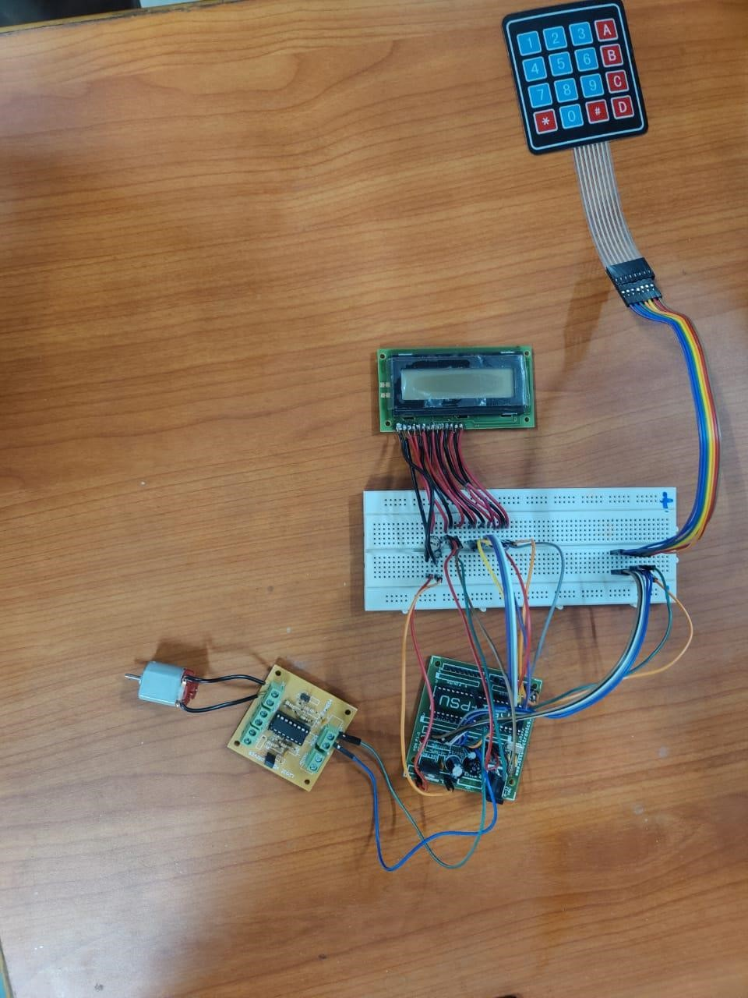

Advantages:

* You won’t have to carry around a large set of keys and they will be less likely to be lost or stolen
* In a company building, you can control and restrict who goes into what part of the building and it reduces the risk of anything getting stolen.
* the prevent break-ins because burglars are unable to pick or ‘bump’ the lock. Criminal’s methods of breaking and entering are improving and the majority of criminals can pick an ordinary key lock.

Conclusion:

In conclusion, the development of an embedded system for door access control through soft keys addresses the common issue of forgetting physical keys. This innovative solution not only enhances convenience but also improves security by allowing access control through password authentication. The integration of soft keys provides a flexible and user-friendly approach, offering both local and remote accessibility for door management. This project aligns with the contemporary need for smart and efficient solutions in access control systems, contributing to a more seamless and secure user experience.

Thank You